**19CSE357 – Big Data Analytics**

**Ex. No: 1 Basic Linux Commands**

1. Display your current directory. (**pwd**)

* 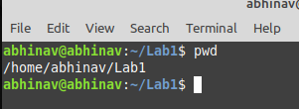

1. List the contents of the root directory. ( **ls**)

* 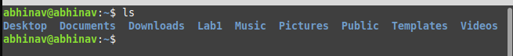

1. List a long listing of the root directory. ( **ls -l**)

* 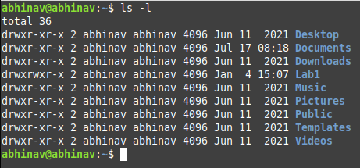

1. Stay where you are, and list the contents of /etc. ( **ls /etc**)

* 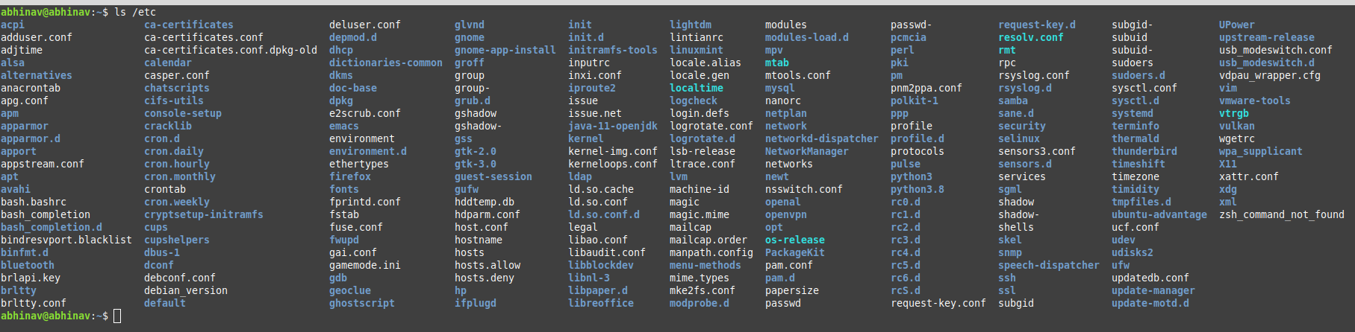

1. Create a directory testdir in your home directory.

* **mkdir Sample**
* 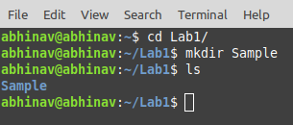

1. Remove the directory sample.

* **rmdir Sample/**
* 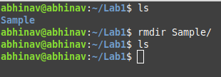

1. Create the files today.txt and yesterday.txt in folder all in desktop

* 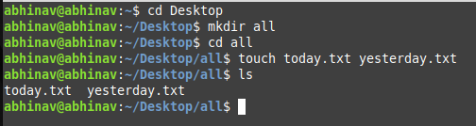

1. Move folder all to sample folder in desktop

* 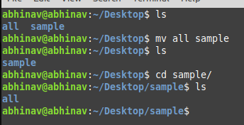

1. Move only the contents of Folder all to Desktop (today.txt and Yesterday)

* mv /home/abhinav/Desktop/sample/all/* /home/abhinav/Desktop
* 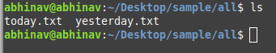

1. Remove folder all

* rm -r /home/abhinav/Desktop/all
* 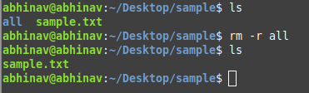

1. Display a list of all logged on users.

* **who**
* 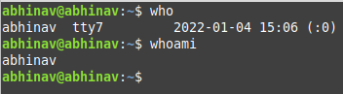

1. Create a user account named serena, including a home directory and a description (or comment) that reads Serena. Do all this in one single command.

* **sudo useradd -m -c 'Serena Williams' serena**
* 

1. Use su to switch to another user account and display the home directory of serena

* 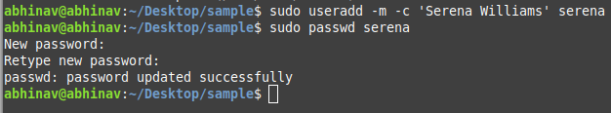
* 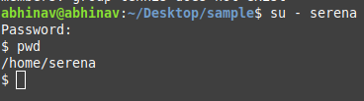

1. Delete the user Serena

* **sudo userdel -r serena**
* 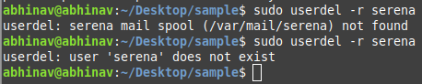

1. List the files with their access permissions for sample.txt Change the permission of file sample.txt in desktop to all users

* **ls -l**

**chmod 777 sample.txt**

* 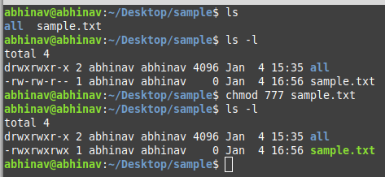

1. Give only read permission for group users in sample.txt file

* **chmod 747 sample.txt**
* 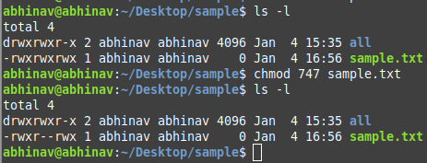

1. Find the difference between su and sudo command

* The su command allows you to swtich user and run your commands as some other user under their user ID.
* su requires the password of the target account, while sudo requires the password of the current user.

1. Create the groups tennis

* **sudo addgroup tennis**
* 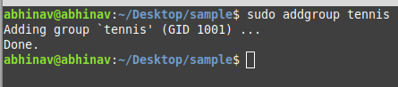

1. In one command, make serena a member of tennis

* **sudo usermod -a -G tennis serena**
* 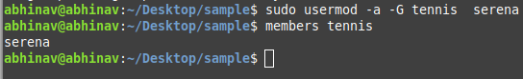

1. Delete the group

* sudo groupdel tennis
* 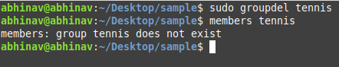

**Evaluation 1 - Linux Commands**

1. Find out the users who are currently logged in

* 

1. Display the name of your home directory.

* 

1. Create a directory SAMPLE under your home directory.

* 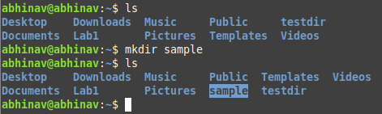

1. Create a sub-directory by name TRIAL under SAMPLE.

* 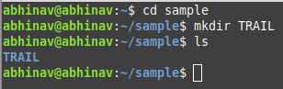

1. Change from home directory to TRIAL by using absolute and relative pathname.

* 

1. Remove directory TRIAL.

* 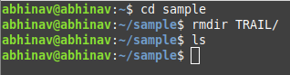

1. Create files myfile and yourfile under SAMPLE Directory.

* 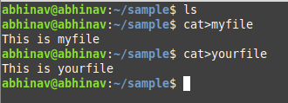

1. Remove SAMPLE directory with files by using a single command.

* 

1. Is there any command available to get back a deleted file?

* undelete
* lsof

1. Login as root and create groups as dba with id 501 & stud with id 555

* 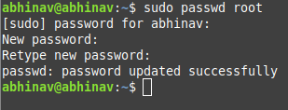
* 

1. Create the following list of users

User name UID GID Working Shell Secondary Comments Group

Mac1 501 501 Bourne shell 555 Mac1 user

* 

1. Identify the available memory in the system.

* 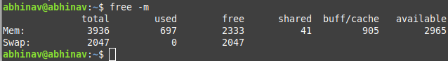

1. Login as a normal user

* 

1. Create file test

* 

1. Find the permissions of file test

* 

1. Change the ownership of the file to MAC1

* 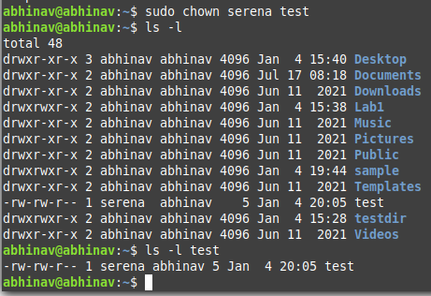

1. Switch to Super User Account

* 

1. Change group of file test

* 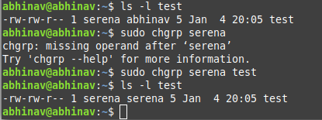

1. Create a file testfile in testdir:
   * 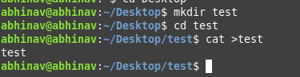
2. Verify the ownership and the group of the testfile
   * 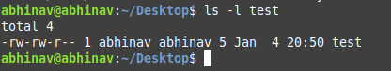
3. Create three sample directories with some files to use with the tar command.
   * 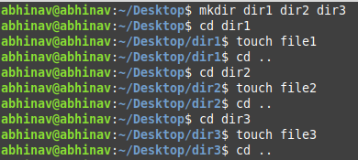
   * 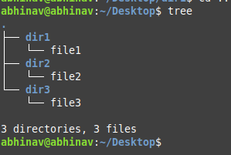
4. Use the tar command to backup all three directories into single tar file.
   * 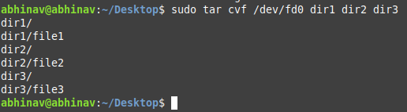
5. List the directory that contains binary files in your system
   * 
6. Difference between su and sudo– command.
   * The su command allows you to switch user and run your commands as some other user under their user ID.
   * su requires the password of the target account, while sudo requires the password of the current user.
7. List the directory that holds the configuration files.
   * ls /etc
   * 